**LUXURIOUS CREATION:**

**Visualize Around Yourself with AR**



**UNIVERSITY OF ENGINEERING**

**&**

**MANAGEMENT, JAIPUR**

**LUXURIOUS CREATION:**

**Visualize Around Yourself with AR**

Submitted in the partial fulfilment of the degree of

**BACHELOR OF TECHNOLOGY**

In

**COMPUTER SCIENCE & ENGINEERING**

Under

**UNIVERSITY OF ENGINEERING & MANAGEMENT, JAIPUR**

By

**PULKIT KUMAR VERMA**

**University Roll No.: 12022002001131**

**University Registration no: 204202200200179**

**ARADHYA PANDEY**

**University Roll no: 12022002001044**

**University Registration no: 204202200200049**

**ANKITA YADAV**

**University Roll no: 12022002001085**

**University Registration no:** **204202200200089**

UNDER THE GUIDANCE OF

**PROF. JYOTI KHANDELWAL**

COMPUTER SCIENCE & ENGINEERING



UNIVERSITY OF ENGINEERING & MANAGEMENT, JAIPUR

**Approval Certificate**

This is to certify that the project report entitled “**Luxurious Creation: Visualize Around Yourself with AR”** submitted by **Pulkit Kumar Verma** (Roll:**12022002001131**), **Aradhya Pandey** (Roll:**12022002001044)** and **Ankita Yadav** (Roll:**12022002001085**)in partial fulfilment of the requirements of the degree of **Bachelor of Technology** in **Computer Science & Engineering** from **University of Engineering and Management, Jaipur** was carried out systematically and procedurally to the best of our knowledge. It is the bonafide work of the candidate and was carried out under our supervision and guidance during the academic session of 2022-2026.

_______________________

**Prof. Jyoti Khandelwal**

Project Guide, Assistant Professor (CSE)

UEM, JAIPUR

_______________________ ______________________

**Prof. Mrinal Kanti Sarkar** **Prof. A Mukherjee**

HOD (CSE) Academics Dean

**ACKNOWLEDGEMENT**

The endless thanks go to the Lord Almighty for all the blessings he has showered on me, which has enabled me to write this last note in our project work. During the period of our work, as in the rest of our lives, we have been blessed by the Almighty with some extraordinary people who have spun a web of support around us. Words can never be enough to express how grateful we are to those incredible people in our lives who made this thesis possible. We want to thank them for making our time during our work in the institute a period we will treasure. We are deeply indebted to our project supervisor, Prof. Jyoti Khandelwal. Each meeting with her added in valuable aspects to the implementation and broadened our perspective. She has guided us with her invaluable suggestions, lit up the way in our darkest times and encouraged us a lot in academic life.

Pulkit Kumar Verma

Aradhya Pandey

Ankita Yadav

**ABSTRACT**

The "Luxurious Creation: Visualize Around Yourself with AR" project aims to revolutionize furniture shopping websites by incorporating augmented reality (AR) technology. Leveraging the power of AR, users will be able to visualize how various furniture pieces would look and fit within their own living spaces before making a purchase decision. The project involves the development of an innovative website that seamlessly integrates AR capabilities, allowing users to interact with virtual furniture in real-time. Augmented reality can significantly impact the furniture industry, providing customers with a novel and immersive shopping experience, and empowering them to make well-informed buying decisions from the comfort of their homes by bridging the gap between virtual shopping and real-world applications. The project aims to enhance customer confidence and satisfaction, minimize returns, and revolutionize the way furniture shopping is conducted online. The project's key objectives include augmented reality integration, a user-friendly interface, and mobile compatibility.

**Keywords:** Augmented reality, virtual integration, online shopping.

**TABLE OF CONTENTS**

TABLE OF CONTENTS 1

1. INTRODUCTION 2

1.1. AR INTEGRATED WEBSITE 2

1.2. AIM OF LUXURIOUS CREATION 2

1.3. ADVANTAGE OF LUXURIOUS CREATION 2

1.4. TECHNOLOGIES USED IN LUXURIOUS CREATION 3

1.5. FLOW CHART 4

2. TECHNICAL OVERVIEW 5

2.1. AUGMENTED REALITY (AR) AND ITS IMPACT 5

2.2. 3D MODEL AND ITS USE 6

2.3. ROLE OF HTML, CSS AND DATABASE IN USER EXPERIENCE 7

2.4. INTEGRATION OF AR, CSS, HTML AND DATABASE 8

3. RESULTS AND DISCUSSION 10

4. CONCLUSION AND FUTURE SCOPE 17

5. REFERENCE 18

**CHAPTER 1**

**INTRODUCTION**

* 1. **AR Integrated Website**

Augmented Reality (AR) in web development refers to the integration of AR technology in web applications, allowing users to interact with virtual objects via web-based environments. This enhances the user experience and creates immersive and engaging web applications.

* 1. **Aim Of Luxurious Creation**

This encourages the user to buy furniture online by providing a user-friendly environment. The problem of size and colour is being solved. A customization feature is also provided. It will lower the return of items due to any issue caused by shopping online.

* 1. **Advantage Of Luxurious Creation**

1. **Interactive Product Visualization:** Utilizing AR allows customers to virtually place furniture items in their own living spaces, enhancing the online shopping experience by providing a realistic preview of how the items will look in their homes.
2. **Engaging User Interface (UI):** HTML, CSS, and JavaScript enable the creation of a visually appealing and user-friendly interface, enhancing navigation and making the website more engaging for visitors.
3. **Real-time Customization:** JavaScript can be used to implement real-time customization features, allowing users to modify furniture colours, materials, or dimensions instantly, providing a personalized shopping experience.
4. **Seamless 3D Models Integration:** AR can seamlessly integrate 3D models of furniture into the website, allowing customers to view products from different angles and explore intricate details before making a purchase.
   1. **Technologies Used In Luxurious Creation**

Luxurious creations often incorporate advanced technology to enhance their appeal and functionality. Some common technologies used in luxury products include:

1. **HTML5:** HTML5 is the latest version of Hypertext Markup Language, used for structuring content on the web. It introduces new elements, attributes, and APIs for enhanced multimedia, graphics, and interactivity in web pages.
2. **Cascading Style Sheets (CSS):** Cascading Style Sheets (CSS) is a style sheet language used to design the presentation of a document written in HTML or XML. It defines how elements are styled, positioned, and formatted on a webpage, enhancing the visual aspects of the content.
3. **Augmented Reality (AR):** Augmented Reality (AR) is a technology that overlays digital information, such as images, text, or 3D models, onto the real-world environment. This is typically done through devices like smartphones, AR glasses, or headsets, providing an interactive and enhanced experience by blending the physical and digital worlds.
4. **Xampp Server:** Xampp is a free and open-source cross-platform web server solution stack package developed by Apache Friends, consisting mainly of the Apache HTTP Server, Maria DB database, and interpreters for scripts written in the PHP and Perl programming languages. It's commonly used for local development and testing of web applications.
5. **3D Model:** It means the content needs to be realistic, spatial, and engaging. And while there are thousands of apps online, most companies are still figuring out what compelling content looks like in AR. In this post, we’re diving into the role of content in augmented reality, the challenges the industry faces, and the future of spatial content.

These technologies enhance the functionality, aesthetics, and exclusivity of the Luxurious Creation website.

* 1. **Flow Chart**

In Figure 1.1. By opening the website of Luxurious Creation, Users will have the feature of either getting through by logging in (if existing) or registering them on the website or anonymously. The user will interact will the home page, now user can go through the categories part where all the categories of furniture we sell will be listed in the "Explore Categories" section. User will select their desired category and will be redirected to that section in the "Category" tab. Now users can see the 3D view of all the furniture/products by clicking the "View in AR" button. If they are using an Android Device, they can see the model in their space only the 3D model is shown. By choosing the desired colour, if the user wants to get customised, they can fill out the Contact Us form in the "Contact" tab Now after finalizing the product design and colour, the process will proceed forward by completing the transaction stage, after certain days, the user can fill the feedback form in "Feedback" tab and share their experience through it.

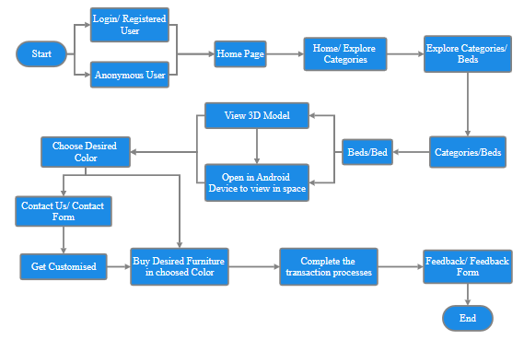Figure 1.1. Luxurious Creation Flow Chart

**CHAPTER 2**

**TECHNICAL OVERVIEW**

* 1. **Augmented Reality (AR) And Its Impact**
     1. **Augmented Reality**

Augmented reality (AR) is an enhanced version of the real physical world that is achieved using digital visual elements, sound, or other sensory stimuli and delivered via technology. It is a growing trend among companies involved in mobile computing and business applications. Amid the rise of data collection and analysis, one of augmented reality’s primary goals is to highlight specific features of the physical world, increase understanding of those features, and derive smart and accessible insight that can be applied to real-world applications. Such big data can help inform a company’s decision-making and gain insight into consumer spending habits, among others [1].

* + 1. **Impact Of User Experience In AR**

The user experience in Luxurious Creation by a brand like "AR" is influenced by several key factors:

1. **Quality and Craftsmanship:** The attention to detail, precision, and the use of high-quality materials contribute to a luxurious experience.
2. **Design and Aesthetics:** Luxury products often feature unique and visually appealing designs that enhance the user's perception of exclusivity and beauty.
3. **Brand Reputation:** The reputation and heritage of the brand can significantly impact the user's perception of the product and its value.
4. **Price:** The high cost of luxury items can create a sense of exclusivity and set expectations for top-notch quality and service.
5. **Exclusivity:** Limited edition or bespoke offerings can make users feel special and unique.
6. **Customer Service:** Exceptional customer service, including personalized experiences and after-sales support, can enhance the overall user experience.
7. **Cultural and Social Significance:** Luxury products often carry cultural and social symbolism, which can affect how users feel about owning and using them.
8. **Sustainability and Ethical Practices:** Some users may consider a brand's commitment to sustainability and ethical practices when evaluating the luxury experience.
9. **Innovation and Technology:** The integration of innovative technologies in luxury creations can provide a modern and sophisticated user experience.

The user's overall perception and satisfaction with luxurious creations by "AR" depend on a combination of these factors, each contributing to the overall experience of exclusivity, quality, and prestige.

* 1. **3D Models And Its Use**
     1. **3D Model**

Content is constantly changing. Designed for TVs and devices in the early 2000s, it now transcends the 2D realm and comes to the world around it. 3D augmented reality content needs to be as immersive as VR advocates ever dreamed, minus the isolation from the outside world. The more AR becomes part of our lives, the higher the need for content to adapt to the 3D world. It means the content needs to be realistic, spatial, and engaging. And while there are thousands of apps online, most companies are still figuring out what compelling content looks like in AR. In this post, we’re diving into the role of content in augmented reality, the challenges the industry faces, and the future of spatial content [4].

* + 1. **Using 3D Model In AR**

To use 3D models in Augmented Reality (AR) in today's world, you can follow these general steps:

1. **Choose a Platform:** Select an AR platform or app development environment, such as ARKit for iOS, AR Core for Android, Unity with AR Foundation, or third-party tools like Vuforia [1].
2. **Create or Obtain 3D Models:** You can create 3D models using software like Blender, and Maya, or use pre-made models from online repositories or 3D marketplaces. Make sure your 3D models are in a format compatible with your chosen AR platform [4].
3. **Prepare Your AR Environment:** Set up your AR development environment with the necessary SDKs and libraries. Install the required software and tools on your development machine [1].
4. **Import 3D Models:** Import your 3D models into your chosen AR development environment. This usually involves adding the 3D models to your project's assets or resources [4].
5. **Develop AR Application:** Write code to integrate your 3D models into your AR application. Depending on the platform, you may use C#, Swift, or other programming languages [4].
6. **Implement Tracking:** Implement object recognition or tracking to anchor your 3D models in the real world. AR platforms like ARKit and AR Core provide tools for this [1].
7. **Add Interaction:** Enhance your AR experience by adding interactivity to your 3D models. This can include gestures, animations, or real-time data [1].
8. **Test Your AR App:** Test your AR application on the target devices to ensure that the 3D models appear correctly in the augmented world and that the tracking and interactions function as expected [1].
9. **Optimize for Performance:** Optimize your AR app for performance to ensure smooth and responsive 3D model rendering [4].
10. **Deploy and Distribute:** Publish your AR application to the respective app stores (e.g., Apple, App Store, Google Play Store) or distribute it via other means [1].

1. **User Engagement:** Consider user engagement and feedback to improve the AR experience and potentially add more 3D models or features [4].

Remember that the specific steps and tools you use can vary depending on the AR platform and the development environment you choose. Additionally, stay updated with the latest AR technologies and practices, as the field is continually evolving.

* 1. **Role of HTML, CSS And Database In User Experience**

HTML, CSS, and databases play essential roles in enhancing the user experience on websites and web applications. Here's how they contribute:

1. **HTML Structure:** HTML provides the basic structure and content of web pages. Well-structured HTML ensures that content is organized logically and accessible. This contributes to a better user experience by making it easier for users to navigate and understand the information presented [2].
2. **CSS Styling:** CSS is responsible for the visual presentation of web pages. By creating visually appealing and consistent designs, CSS can make a website more engaging and user-friendly. It helps in maintaining a consistent look and feel, making navigation and interaction more intuitive [3].
3. **Responsive Design:** CSS also enables responsive web design, which ensures that a website adapts to different screen sizes and devices. This is crucial for a positive user experience, as it allows users to access content seamlessly on smartphones, tablets, and desktops [3].
4. **Interactivity:** HTML and CSS can be used to create interactive elements such as buttons, forms, and animations. These features engage users and make the website more dynamic and interesting [2].
5. **Performance:** Databases are crucial for storing and retrieving data efficiently. A well-optimized database ensures that web applications load quickly and respond to user interactions without delays. This directly impacts the user experience by reducing loading times and ensuring smooth interactions.
6. **Personalization:** Databases store user data and preferences, allowing websites to offer personalized content and recommendations. This customization can greatly enhance the user experience by delivering relevant information and enhancing user engagement.
7. **Search and Navigation:** Databases are used to store data that powers search and navigation features. Effective search functionality and well-organized navigation menus improve the user's ability to find information, which is essential for a positive experience.
8. **Security:** Databases play a critical role in safeguarding user data. Ensuring the security of user information is vital for building trust and providing a safe user experience.
9. **Data Persistence:** Databases enable data persistence, allowing users to save their preferences, shopping carts, and other information. This convenience enhances the user experience, especially in e-commerce and applications that require user accounts.

In summary, HTML, CSS, and databases collectively contribute to a better user experience by structuring and presenting content effectively, creating engaging designs, ensuring responsiveness, providing interactivity, optimizing performance, enabling personalization, improving search and navigation, enhancing security, and offering data persistence. When these elements work together harmoniously, users are more likely to have a positive and enjoyable experience on a website or web application.

* 1. **Integration Of AR, CSS, HTML And Database**

Integrating AR, CSS, HTML, and a database into a luxurious creations website involves combining cutting-edge technology with a visually stunning design. Below is a conceptual example to guide you, in considering a scenario where the website showcases high-end luxury items [4].

* + 1. **HTML And CSS For Frontend**
* Develop an HTML structure for your website, emphasizing a sleek and luxurious design [2].
* Utilize CSS to create an elegant and responsive layout, incorporating high-quality images and typography [3].
  + 1. **Augmented Reality (AR)**
* Integrate an AR library or framework that complements the luxury theme, ensuring it enhances the user experience [1].
* Incorporate AR elements showcasing 3D models of luxury items or interactive features [1].
  + 1. **Database Integration**
* Set up a backend using technology like Node.js and connect it to a database to store information about luxury items.
* Design the database schema to accommodate details such as product name, description, price, and 3D model URLs.
  + 1. **Frontend-Backend Interaction**
* Use JavaScript to make asynchronous requests from the frontend to the backend, fetching and updating AR-related data.
* Dynamically load AR content based on the retrieved data from the database.

A foundation for integrating AR, CSS, HTML, and a database into a luxurious creations website. Tailor it to fit the specific requirements and aesthetics of your luxury brand.

**CHAPTER 3**

**RESULTS & DISCUSSION**

In Figure3.1. and Figure 3.2., the user will get to know about Luxurious Creation, its motive and the section under which it is providing services.

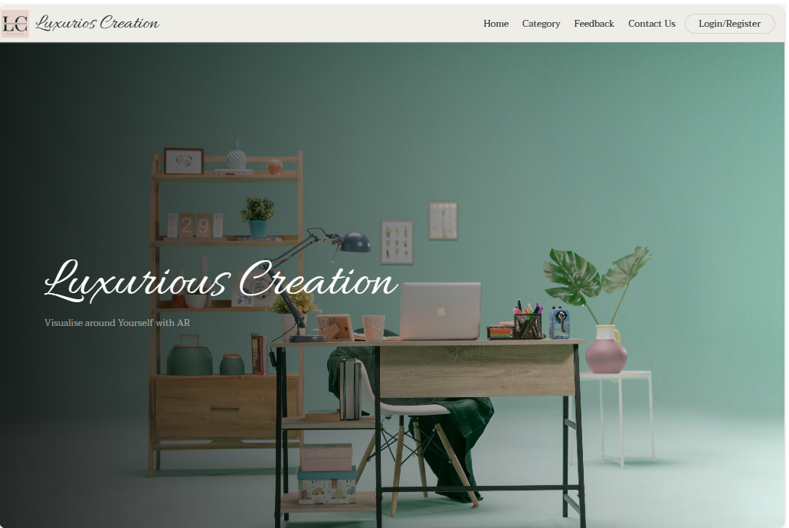

Figure 3.1. - Luxurious Creation/Home

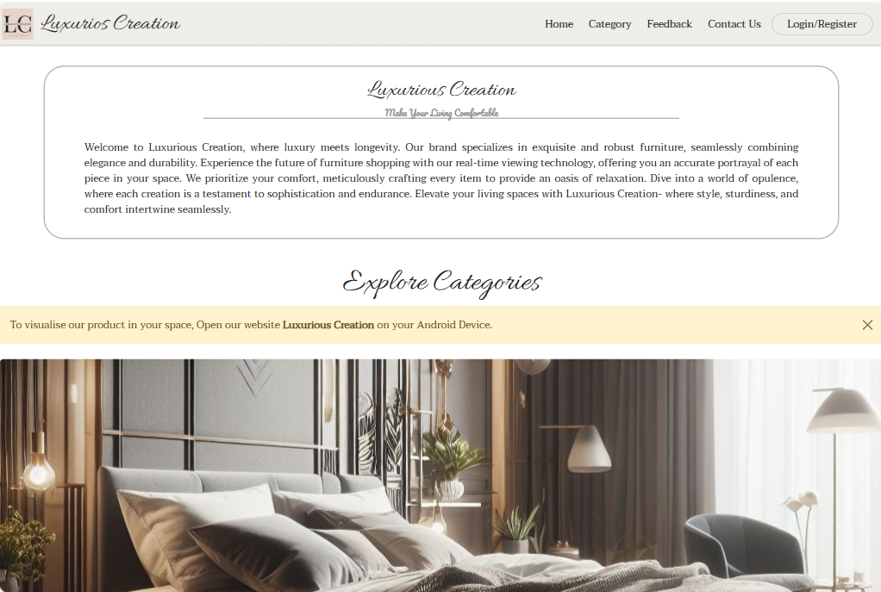

Figure 3.2. - Luxurious Creation/Home

In Figure 3.3. and Figure 3.4., user can explore different sections where a variety of furniture are listed on the website for selling and personalized customization and by feeling the furniture in their space.

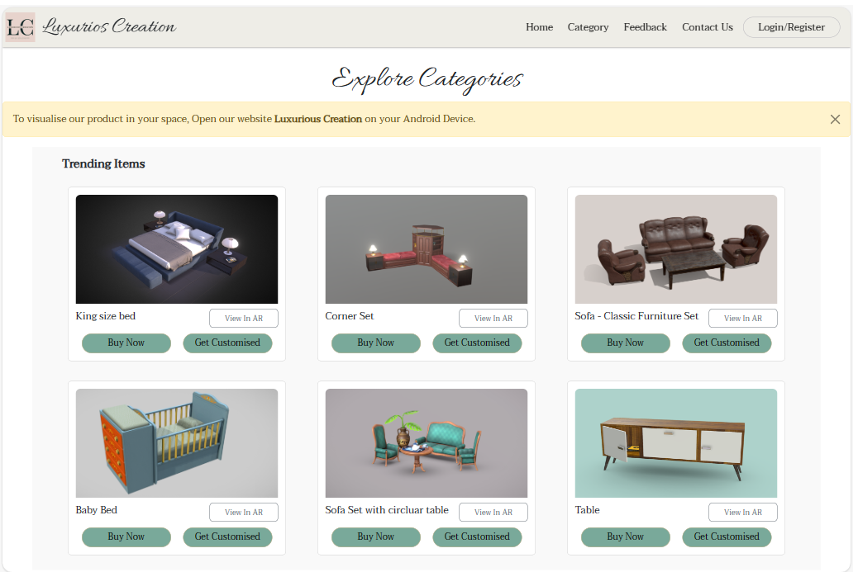

Figure 3.3. - Luxurious Creation/Category/Trending Items

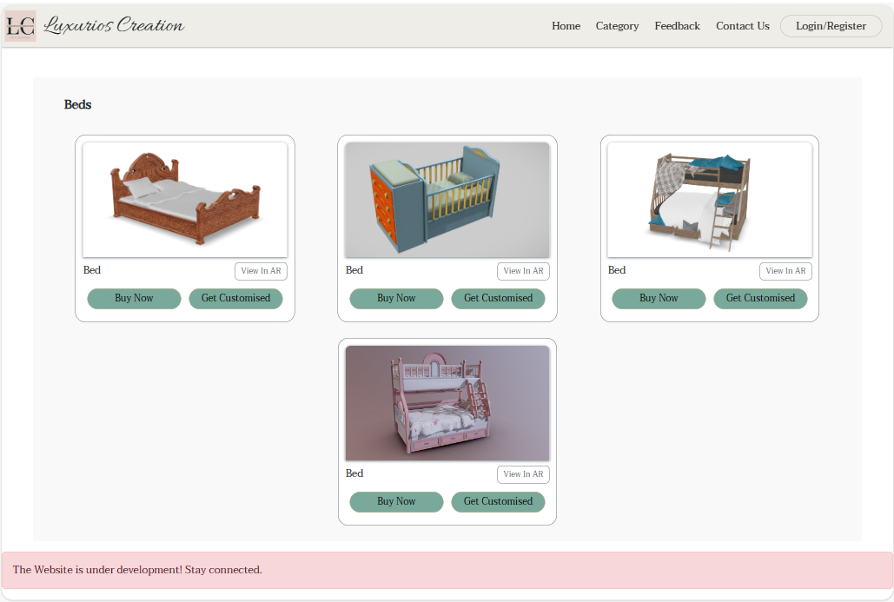

Figure 3.4. - Luxurious Creation/Category/Beds

In Figure 3.5. and Figure 3.6., user can choose the different colour variants of their desired furniture and to view in their space a message is displayed where it is suggested to open on an Android device. Users can resize and rotate the furniture to be satisfied with the furniture model.

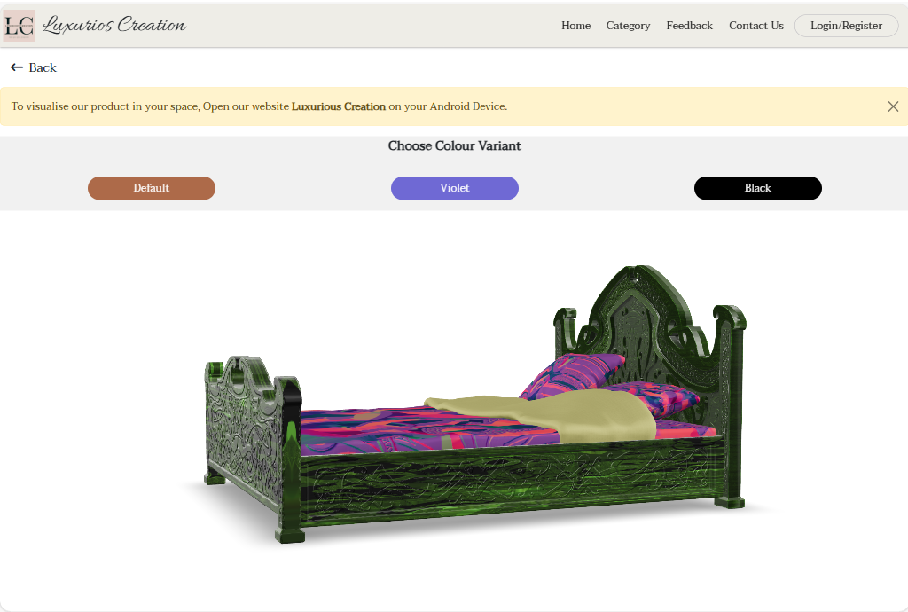

Figure 3.5. - Luxurious Creation/Category/Beds/Bed/Green

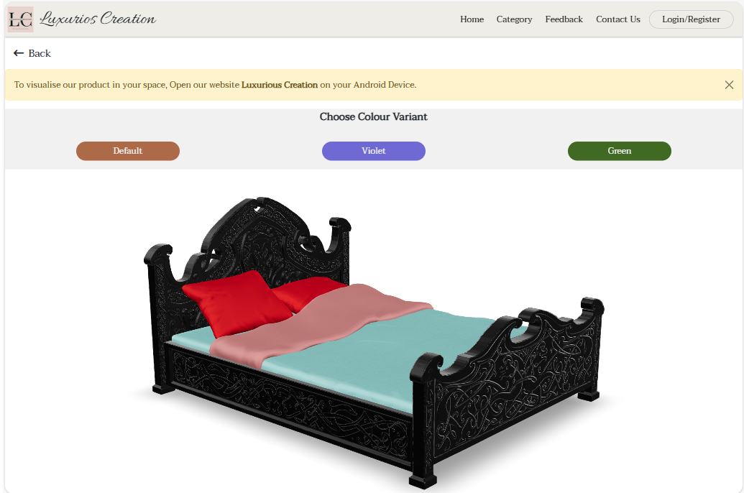

Figure 3.6. - Luxurious Creation/Category/Beds/Bed/Black

In Figure 3.7., user can share their product and website reviews. They can rate the product based on their expectation.

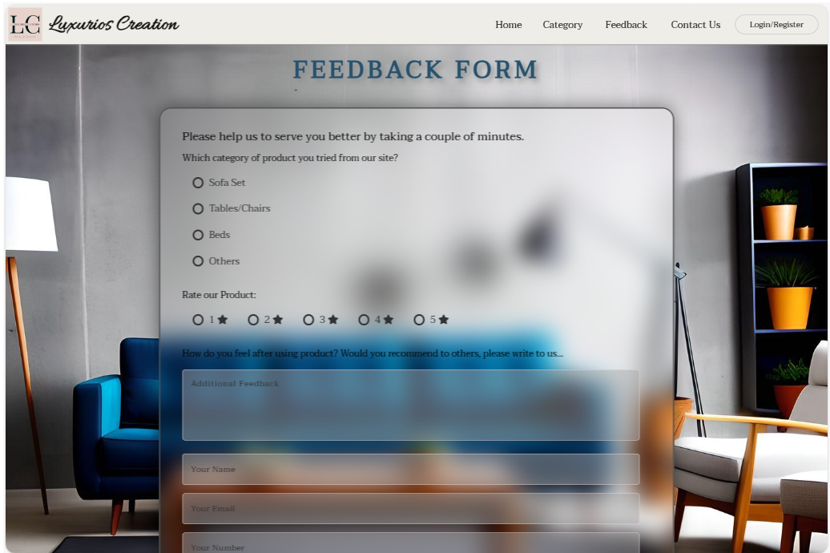

Figure 3.7. - Luxurious Creation/Feedback

In Figure 3.8., the representation of data collection in the backend database of the website is shown. Feedback from customers will be collected here and will be used to improve the quality and services.

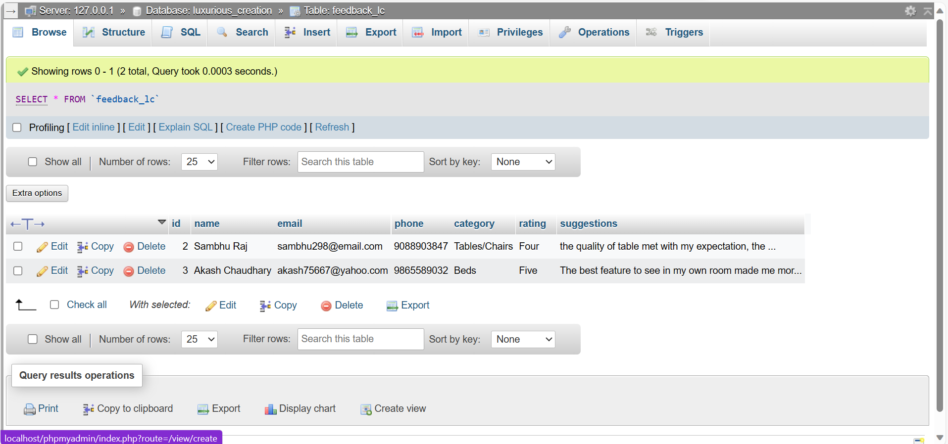

Figure 3.8. – Xampp Server/ luxurious_creation/feedback_lc/Feedback Database Table

In Figure 3.9., users can contact us for any personalized order or any help. They can contact us on social media or through calls or email at their convenience.

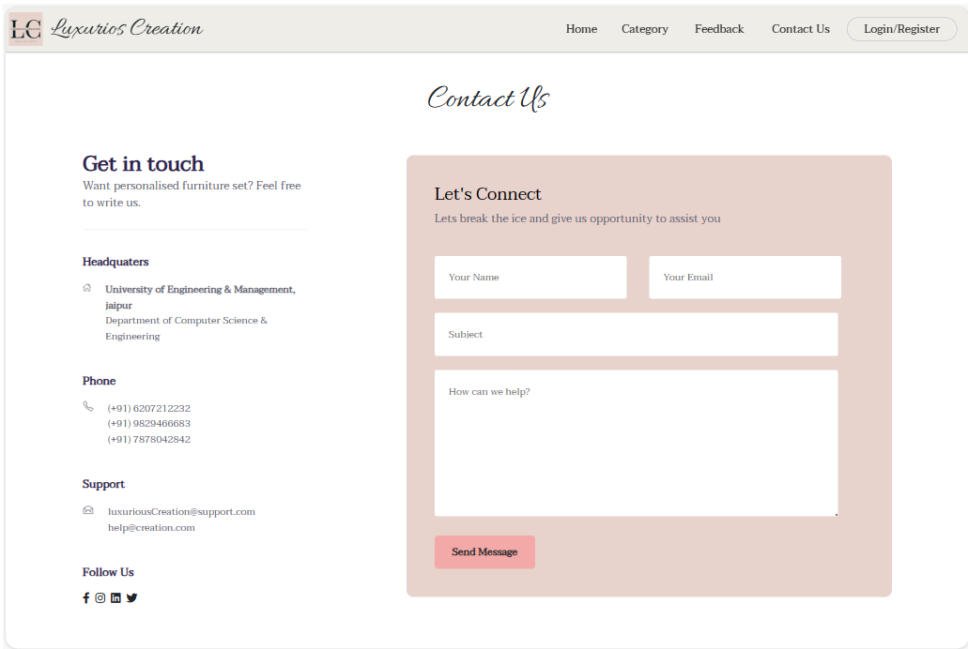

Figure 3.9. - Luxurious Creation/Contact Us/Connect Form

In Figure 3.10., the representation of data collection in the backend database of the website is shown. Requests from customers will be collected here and will be contacted through email and used for improving the quality and services.

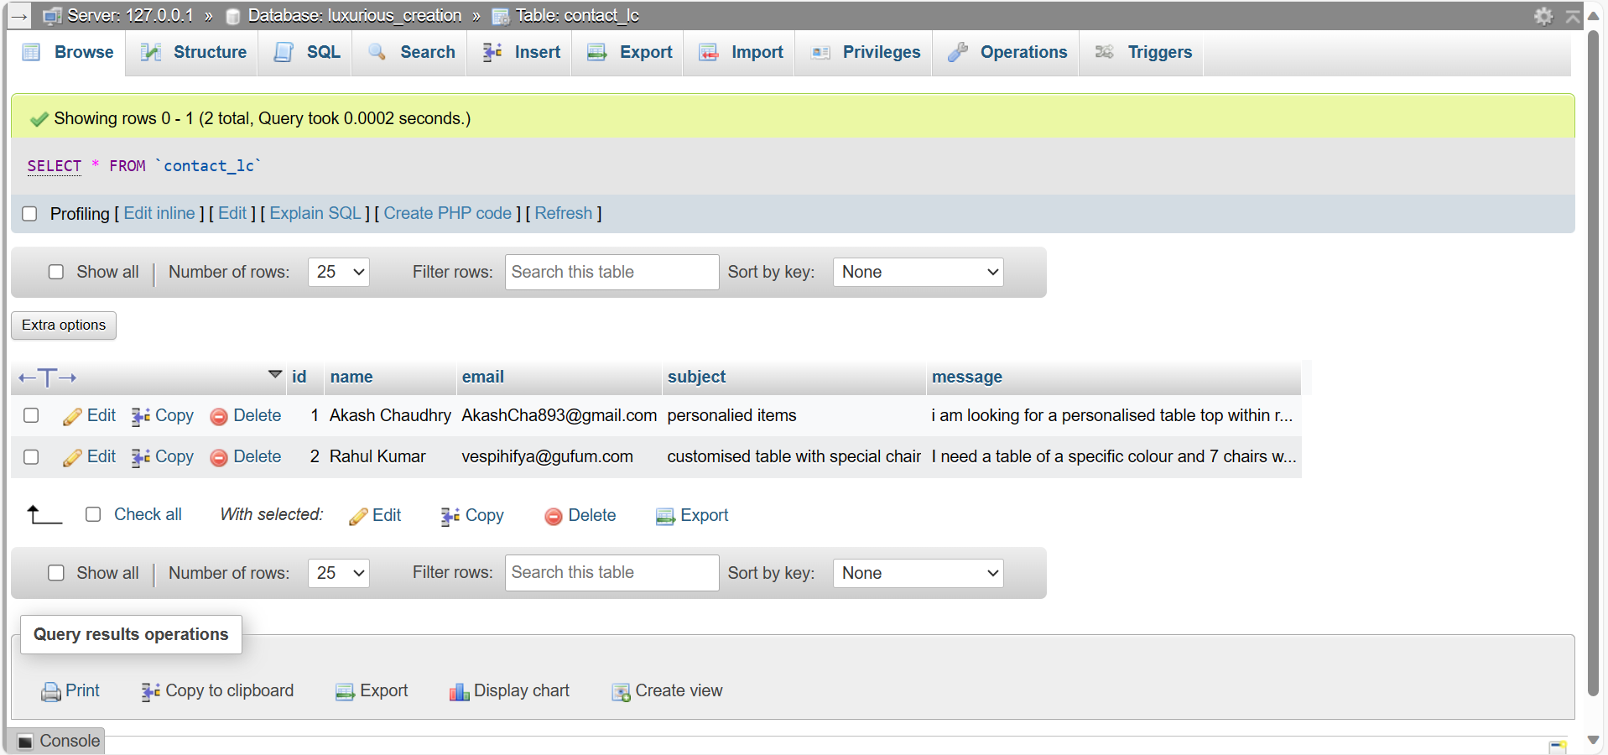

Figure 3.10. – Xampp Server/ luxurious_creation/contact_lc/Contact Database Table

In Figure 3.11., 3.12. and 3.13., users can log in to the website get convenience in ordering the product, register a new account in case of new customer and reset their account password using their username if forget by chance respectively.

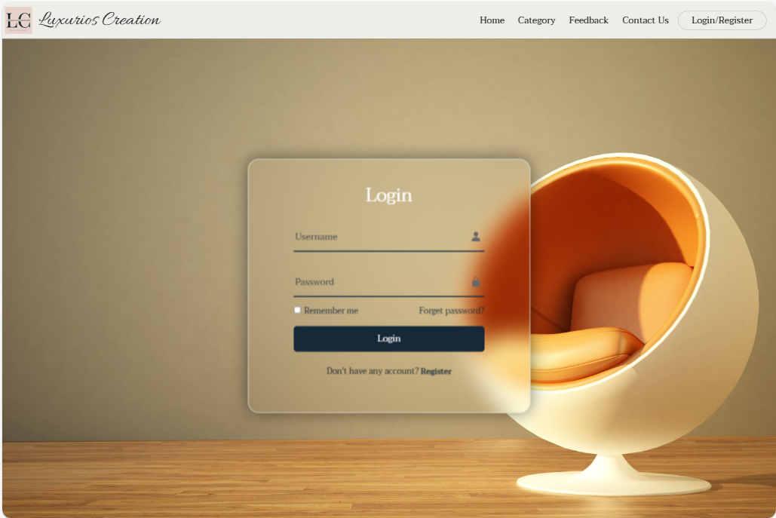

Figure 3.11. - Luxurious Creation/Login-Registration/Login

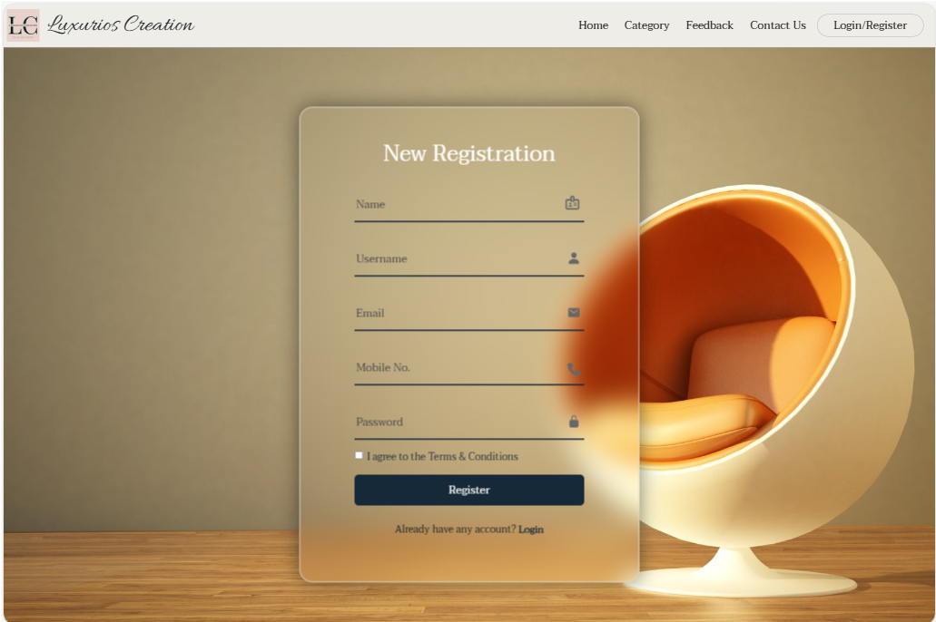

Figure 3.12. - Luxurious Creation/Login-Registration/Registration

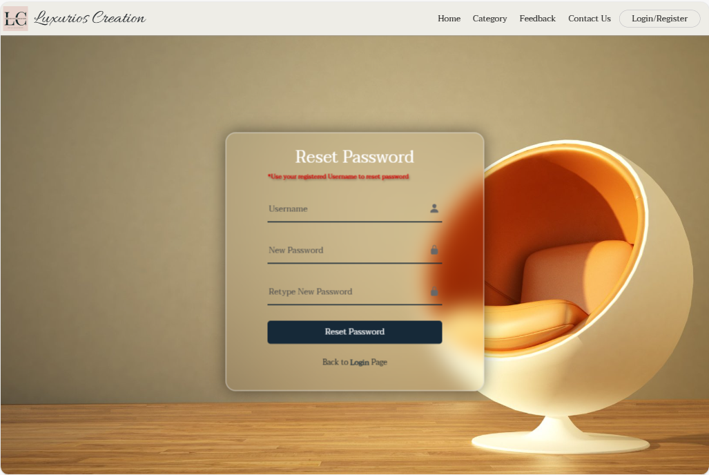

Figure 3.13. - Luxurious Creation/Login-Registration/Reset Password

In Figure 3.14., the representation of data collection in the backend database of the website is shown. New registered account details will be stored here and the user can create a unique username once with each email id.

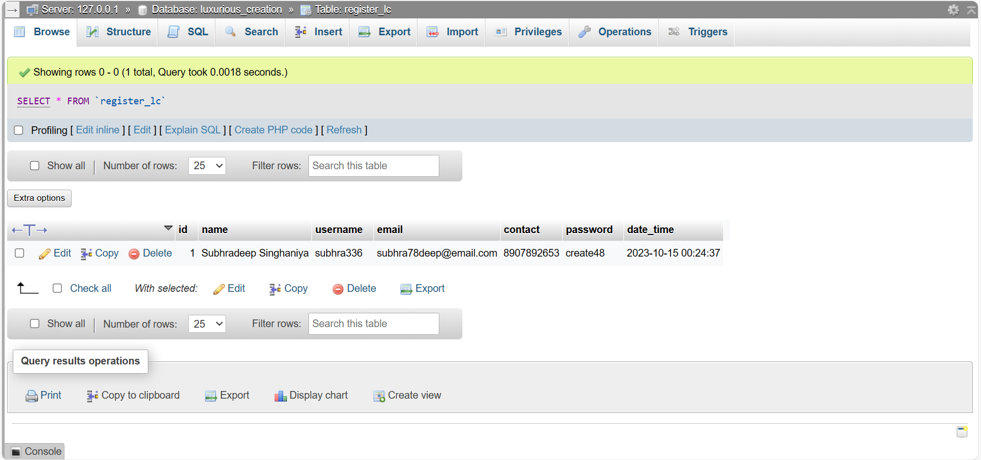

Figure 3.14. – Xampp Server/ luxurious_creation/register_lc/Registered Database Table

**CONCLUSION & FUTURE SCOPE**

Luxurious Creations, the AR-powered furniture website, combines cutting-edge technology with exquisite design, offering users a seamless virtual shopping experience. With augmented reality, customers can visualize furniture in their own spaces before making a purchase, enhancing confidence and satisfaction.

The fusion of technology and craftsmanship positions Luxurious Creations at the forefront of the online furniture market, redefining the way customers engage with and select high-end pieces for their homes.

Luxurious Creations, the furniture website using cool AR stuff, is set for an awesome future! We're thinking about adding more furniture styles and colours for you to pick from. Imagine customizing furniture exactly how users want! And get this – we're looking into making the shopping experience even smarter with things like real-time measurements. Plus, we want others to be able to show off their new furniture on social media. So, Luxurious Creations is planning to make buying furniture online really fun and easy, with lots of cool options for users.

**REFERENCES**

[1] Saidin, N. F., Abd Halim, N. D., & Yahaya, N. (2015). A review of research on augmented reality in education: Advantages and applications. *International Education Studies*, 8(13). https://doi.org/10.5539/ies.v8n13p1

[2] Peroni, S., Osborne, F., Di Iorio, A., Nuzzolese, A. G., Poggi, F., Vitali, F., &amp; Motta, E. (2017). Research articles in Simplified HTML: A web-first format for HTML-based scholarly articles. *PeerJ Computer Science*, 3. https://doi.org/10.7717/peerj-cs.132

[3] Genevese, P., Lanadia, N., &amp; Quint, V. (2012, April). on the analysis of Cascading Style_Sheets_Researchgate.https://www.researchgate.net/publication/254008906_On_the_Analysis_of_Cascading_Style_Sheets.

[4] Paula. (n.d.). Creating 3D content for augmented reality. (2020, May 3). wikitude.https://shorturl.at/oLQX0